**TRAINING PROJECT DOCUMENTATION**

Undertaken at

**NIIT-NEXWAVE LEARNING MANAGEMENT SOLUTIONS**

Bengaluru

On

**ONLINE WEATHER APPLICATION**

*Submitted by*

PRIYANKA PARTHIBAN

SRIJANI CHAKRABORTY

PIYUSH BISHT

SUDEEP VARSHNEY

NAZAM SHARM­­A

*Under the guidance of*

MR. SURENDRAN VELATH

**ABSTRACT**

Weather forecasting is a vital application in meteorology and has been one of the most scientifically and technologically challenging skill around the world involving observation and processing of vast amounts of data. A platform that provides quick updates on the current weather status of a required location will be effective as it makes it easy to handle not only our activities, but also our livelihoods too. The simpler it is the better as the primary users are the general public. Thus, the application of emerging technologies for increasing the ease of availability of the weather forecast calls for special attention.

**TABLE OF CONTENTS**

**Abstarct......................................................................................................................2**

**Table of Contents......................................................................................................3**

**List of Figures............................................................................................................4**

**CHAPTER 1: INTRODUCTION...................................................................................5**

**CHAPTER 2: SOFTWARE REQUIREMENT SPECIFICATION…………...................6**

2.1: Software Development Life Cycle.........................................................................6

2.1.1: Waterfall Model…………………….................................................................6

2.2: Functional Requirements……………………………...............................................8

2.3: Non-Functional Requirements..............................................................................8

2.3.1: Hardware Specifications……………..............................................................8

2.3.2: Software Specifications….…………...............................................................8

**CHAPTER 3: UML DIAGRAMS ...............................................................................10**

3.1: Use Case Diagram..............................................................................................10

3.2: Sequence Diagram..............................................................................................11

3.3: Activity Diagram...................................................................................................13

**CHAPTER 4: GUI DESIGN SCREENSHOTS...........................................................14**

4.1: Welcome Page....................................................................................................14

4.2: Login Page………................................................................................................14

4.3: Registration Page................................................................................................15

**CHAPTER 4: CONCLUSION....................................................................................16**

**LIST OF FIGURES**

**Chapter 2**

Figure 2.1: Software Development Life Cycle…………………….................................6

Figure 2.2: Waterfall Model..........................................................................................7

**Chapter 3**

Figure 3.1: Use Case Diagram for Online Weather Application................................10

Figure 3.2: Sequence Diagram for Login Page.........................................................11

Figure 3.3: Sequence Diagram for Register Page.....................................................11

Figure 3.4: Sequence Diagram for Viewing Weather of Required City......................12

Figure 3.5: Sequence Diagram for Viewing Cities with Specific Weather.................12

Figure 3.6: Activity Diagram of Online Weather Application…..................................13

Chapter 4

Figure 4.1: Welcome Page for Weather Application…………………………………...14

Figure 4.2: Login Page for Weather Application………………………………………..14

Figure 4.3: Registration Page for Weather Application………………………………..14

**CHAPTER 1**

**INTRODUCTION**

Weather forecasting is the application of science and technology to predict the state of the atmosphere for a given location. Ancient weather forecasting methods usually relied on observed patterns of events, also termed pattern recognition. For example, it might be observed that if the sunset was particularly red, the following day often brought fair weather. However, not all of these predictions prove reliable. Here this system will predict weather based on parameters such as temperature, humidity and wind. The primary advantage of forecasting is that it provides the business with valuable information that the business can use to make decisions about the future of the organization. It is very important to get educated on the current weather situation of a particular location as preferred since it affects the day to day life of everyone. It is more effective if we can get quickly updated on current weather status of a required location.

This system is a web application with effective graphical user interface. User will login to the system using his user ID and password.  The View is web page in our application which displays the information of cities and weather information as per request and is responsible for rendering the weather data and in general it generates HTML output that the user's browser can interpret.

Spring MVC Framework has been used to create the web application.Spring is the most suitable framework since you can easily change configurations by dependency injection, it addresses end-to-end requirements, is portable across deployment environments and it integrates well with Hibernate which helps in database connectivity. The front end is created using HTML5 and CSS. Using the above the web application can be successfully created in a robust manner.

**CHAPTER 2**

**SOFTWARE REQUIREMENT SPECIFICATION**

**2.1 SOFTWARE DEVELOPMENT LIFE CYCLE**

SDLC is a process followed for a software project, within a software organization. It consists of a detailed plan describing how to develop, maintain, replace and alter or enhance specific software. The life cycle defines a methodology for improving the quality of software and the overall development process.

The following figure is a graphical representation of the various stages of a typical SDLC.

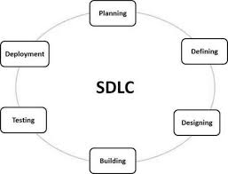

Figure 2.1: Software Development Life Cycle

Following are the most important and popular SDLC models followed in the industry:

* Waterfall Model
* Iterative Model
* Spiral Model
* V-Model
* Big Bang Model

**2.1.1 WATERFALL MODEL**

Waterfall approach was first SDLC Model to be used widely in Software Engineering to ensure success of the project. In "The Waterfall" approach, the whole process of software development is divided into separate phases. In this Waterfall model, typically, the outcome of one phase acts as the input for the next phase sequentially.

The following illustration is a representation of the different phases of the Waterfall Model.

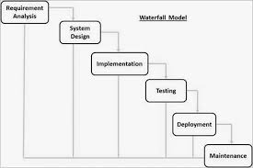

Figure 2.2: Waterfall Model

The different phases are described below.

– **Requirements**

The first step is to gather the requirements that the system must fulfill. This is done by doing consultation with the users of the system. The constraints and goals are defined in detail and serve as a system specification.

– **Design**

The system is thereafter designed, which will partition the requirements into hardware and software systems. The architecture is established by identifying the fundamental software system abstractions and their relationships.

– **Implementation**

After the system is designed a set of programs are implemented and tested. Each unit is tested individually in order to verify that it meets its specification.

– **Testing and Deployment**

The different program units are integrated and tested together to ensure that the system has fulfilled the software requirements. The system is delivered to the customer when all tests have been successfully performed.

– **Maintenance**

The last step includes operation and maintenance of the system. This is normally the longest phase. The system must be adapted to new requirements that have been discovered and errors that were not discovered in earlier stages must be corrected.

The Waterfall approach of software development has been followed in this project to create the Weather App.

**2.2 FUNCTIONAL REQUIREMENTS**

1. **WELCOME PAGE**

This module involves the login into the application.

1. **LOGIN PAGE**

This module involves authorized login into the application by providing the login ID and password. Once authenticated the user is free to access the weather forecast data. If not registered signup to create a new account.

1. **REGISTER PAGE**

This module helps in creating a new account by providing the username, login ID and password. As soon as the account is created it takes the user to the login page where the user has to login using the newly created ID. Once authenticated the user is free to access the weather forecast data.

1. **CHOICE DISPLAY PAGE**

This module gives a choice on the basis of the user requirement. The user can either select to know the weather forecast data of a particular place or can choose to know all the places with the same weather.

**5. CITY DISPLAY PAGE**

In this module, the different weather types are given. Once the weather type is selected, it displays all the cities with the selected weather.

**6. WEATHER DISPLAY PAGE**

This module gives a list of countries and their cities. On selecting the country and city the weather forecast of the selected place is shown.

**2.3 NON-FUNCTIONAL REQUIREMENTS**

**2.3.1 HARDWARE SPECIFICATION**

* Processor : Intel i5 Core CPU
* Speed : 3.30 GHz
* RAM : 8 GB
* System : 64 bit OS

**2.3.2 SOFTWARE SPECIFICATION**

* Operating System : Windows 10 Pro
* Web Server : Apache Tomcat 8.0
* Front End : HTML, CSS, JSP
* Scripts : JavaScript
* Back End : Spring MVC, JPA Hibernate
* Database : Oracle
* DB Connectivity : JPA Hibernate

**CHAPTER 3**

**UML DIAGRAMS**

**3.1 USE CASE DIAGRAM**

The use case begins by the user logging into the website and then is presented with a list of countries and cities. After selecting a city from the list, its forecast is displayed to the user.

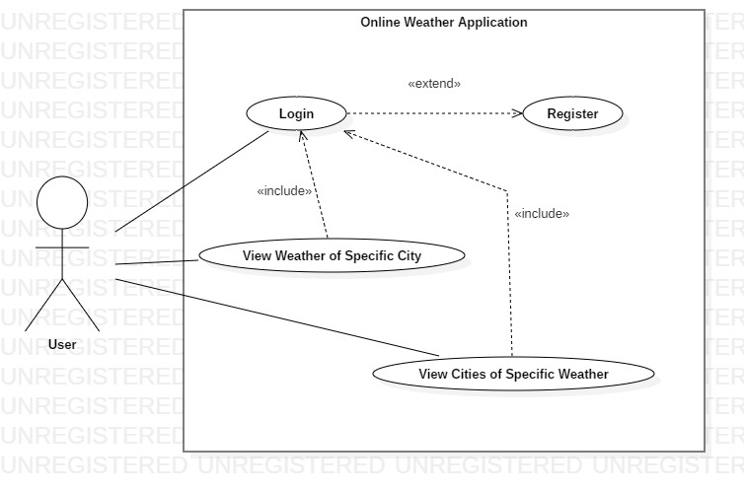

Figure 3.1: Use Case Diagram for Online Weather Application

**3.2 SEQUENCE DIAGRAMS**

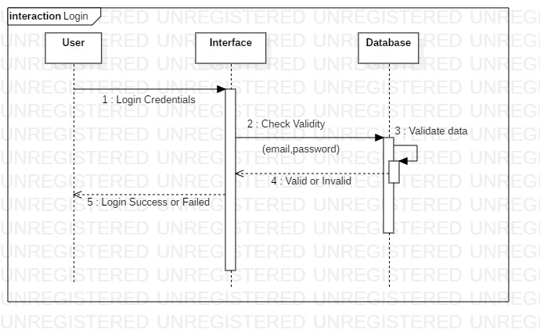

Figure 3.2: Sequence Diagram for Login Page

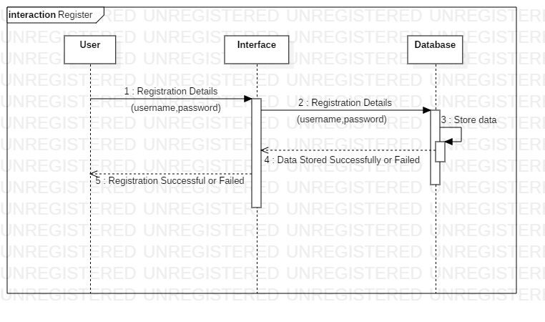

Figure 3.3: Sequence Diagram for Register Page

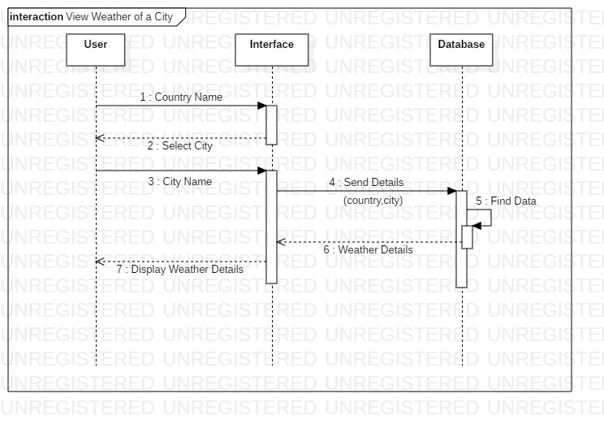

Figure 3.4: Sequence Diagram for Viewing Weather of Required City

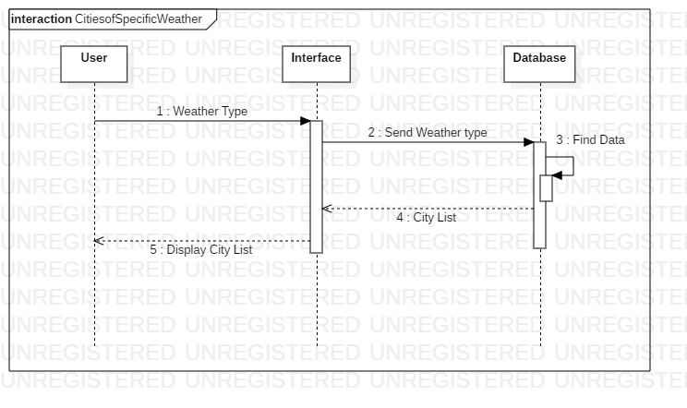

Figure 3.5: Sequence Diagram for Viewing Cities of Specific Weather

**3.3 ACTIVITY DIAGRAM**

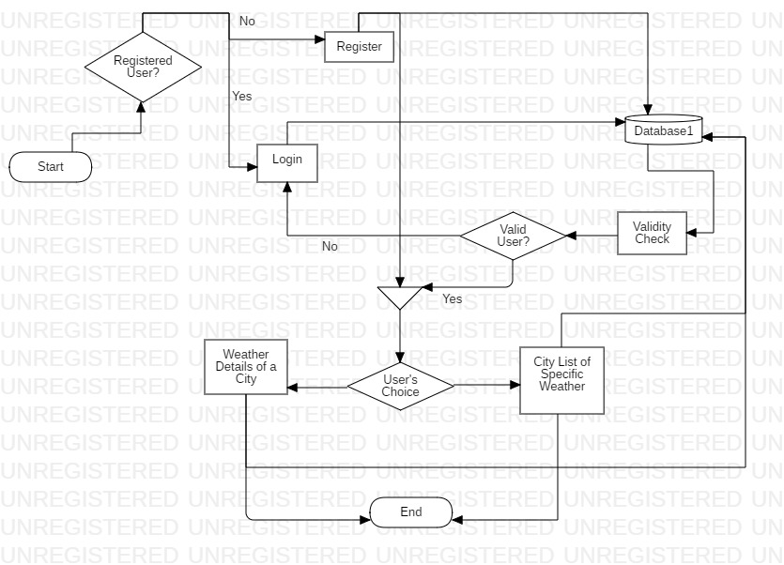

Figure 3.6: Activity Diagram of Online Weather Application

**CHAPTER 4**

**GUI DESIGN SCREENSHOTS**

**4.1 WELCOME PAGE**

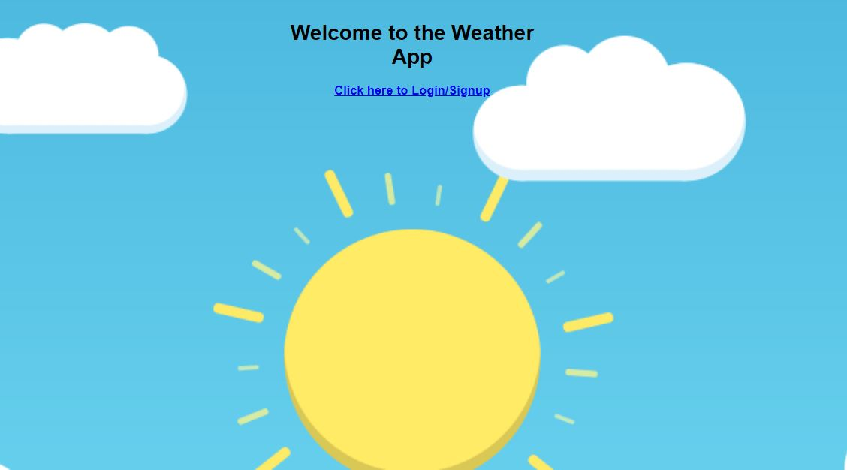

Figure 4.1: Welcome Page for Weather Application

**4.2 LOGIN PAGE**

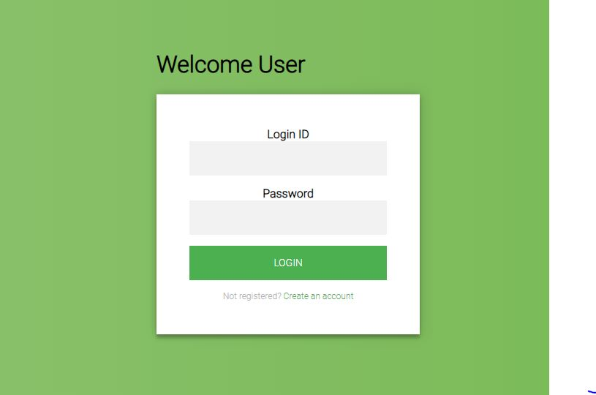

Figure 4.2: Login Page for Weather Application

**4.3 REGISTRATION PAGE**

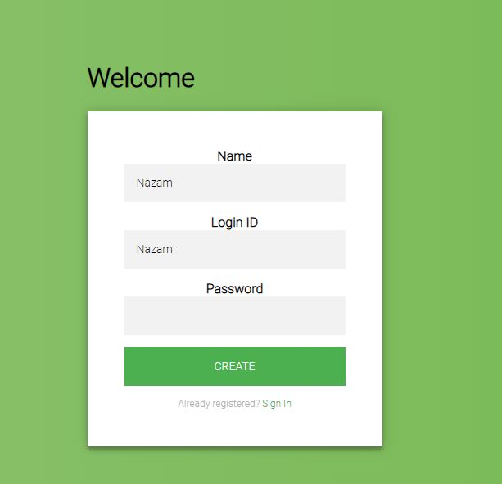Figure 4.3: Registration Page for Weather Application

**CHAPTER 4**

**CONCLUSION**

A good weather application can be used for simple decision-making, such as determining whether you'll need to bring an umbrella to work, or for more serious preparation and warnings. With dangerous weather conditions across the country, and especially hurricanes threatening coastal states, it's a good idea to check the forecast or radar for upcoming conditions. An ideal weather app is visually pleasing and easy to use. The accuracy of weather forecasting is emerging to be very important in terms of day to day lives as well as in many fields such as marine, aviation and many more.

The project involves a specific dataset which can be enhanced to provide more data including more detailed weather status making it more accurate. The website can be made to display real time weather status for various locations using Open Weather App weather service which can be referenced into the project. Weather forecasting applications thus proves to be a developing field in terms of accuracy and ease of availability.